Dear friends and family-

We send Holiday blessings and this message of hope and joy amidst the desolation…heard at

A Celtic Christmas Sojourn:

*There Are Also Musicians* by Michael Coady

Though there are torturers in the world; There are also musicians.

Though, at this moment, Men are screaming in prisons; There are jazzmen raising storms of sensuous celebration, and orchestras releasing Glories of the Spirit.

Though the image of God Is everywhere defiled;

A man in West Clare Is playing the concertina, the Sistine Choir is levitating Under the dome of St. Peter's, and a drunk man on the road Is singing, for no reason.

Wow, an incredible year for our small family, as well as the country and the world. We won’t focus on the “less good” very much, but rather share the Good News first. In February 2016, we bought our new “downsizing” condo at the beginning of the month; MOVED from our home of 31 years in mid-month; and sold that house at the very end of the month. Even though we only moved 4 blocks away, we had months of unpacking and getting used to our first “new” home EVER (it’s a former church built in 1929, but the interior is totally new construction, except for the windows with a stained-glass perimeter.)

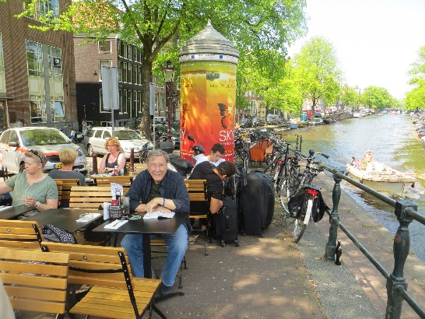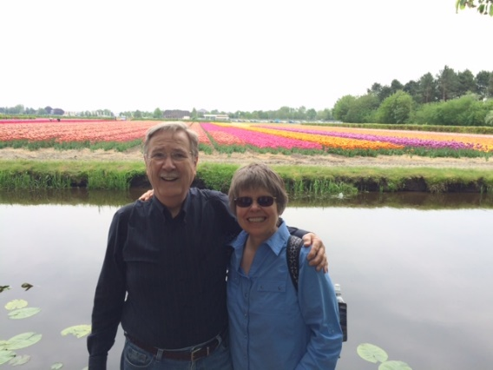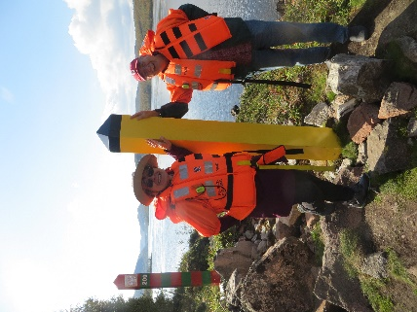

Amsterdam canal scene K and J at Keukenhof Gardens Russia-Norway Border

Bucket List trips: In May, we treated ourselves to an impromptu 8 day visit to Holland to enjoy the end of the Tulip Season! We stayed in our favorite ancient town of Haarlem, which is a 20-minute train ride from the hustle bustle of Amsterdam and a bus ride from the wonderful gardens at Keukenhof. 7 MILLION flowering bulbs are re-planted every year! Our early summer travels were more local, with many visits to our Central PA cottage and a weeklong loop to upstate NY to re-visit friends from college days. In August, a direct flight from Newark took us to Oslo to begin a very cool tour of the fjord-laden coast of Norway on the Hurtigruten “small ship” cruise line…ending in the town of Kirkenes above the Arctic Circle….just kilometers from both Russia and Finland. After a brief respite at home, we headed to Maine for a more relaxed two week visit to our favorite towns: Belfast, Boothbay Harbor and Brunswick/ Bowdoin. Whew…. we were glad to mostly stay home for the past three months of the year.

In between travels and getting organized in our new “digs”, Jerry has continued his work with Habitat for Humanity in Philadelphia…serving on the Board of Directors as well as an important committee; he also served as the first treasurer of our HOA board…with lots of start-up challenges to work out management, budget issues and learn about our new neighbors. Kathy finds joy with her *Heartlights* singers who share the gift of music with nursing home residents. Her Church book group friends challenge her spiritual and intellectual curiosity and provides support. She has signed up for a Refugee Relocation project at Church and looks forward to providing hospitality and support to a new immigrant family.

Having moved back to PA last fall, Melissa bought a home this spring in the quaint “Chautauqua” community of Mt. Gretna…. only a 90-minute drive from Narberth! She and Jerome have been busy getting their “home in the woods” set up, but each enjoying a commute of less than 30 minutes to work. Melissa continues her job as a hospice chaplain. Ben embarked on the 3rd year of his PhD program in Public Policy at Brandeis, and moved into Boston (Dorchester area) in September. It’s a better location for his internships and social life; he has enjoyed doing lots of things with girlfriend Erin.

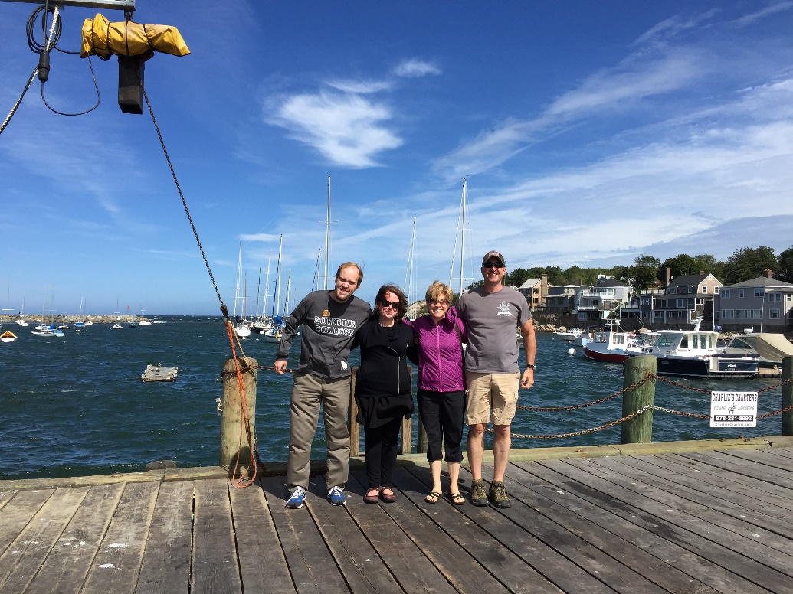 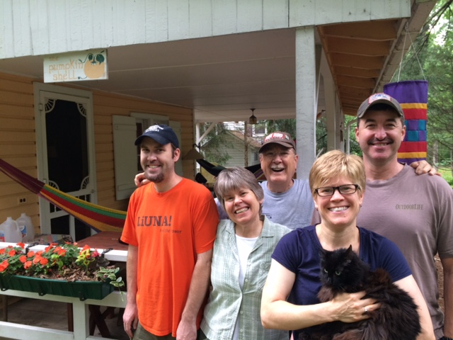

Ben, Erin, Melissa, Jerome in Rockport, MA Ben, K, J, Melissa, Jerome at Waldheim cottage

With the cold weather upon us here in Southeastern PA, we are looking forward to family times over these holidays…. but also to our departure for 5 weeks in Arizona later in January. Besides all of the good things in 2016, we have experienced the unexpected death of a good friend from Harrisburg school days; as well as the drastic declining health of several other long-time friends. In spite of various bodily aches and pains we are fortunate to be pretty active and healthy; turning 70 was sobering, making us realize our mortality. We awaken each day with a prayer of gratitude for good health and special opportunities in our lives.

We hope that this note also finds YOU and your family to be both healthy and happy. The USA and the world will need all of our prayers, as we move into 2017…the Chinese Year of the ROOSTER.

Much Love from Kathy, Jerry, Melissa and Ben

PS: For those receiving this electronically, please share with others in your household…. thanks!