**Former Oregon assistant sues half brother of Jackie Kennedy Onassis**

Updated May 23, 2012; Posted May 23, 2012

Comment

0shares

**By**[**The Associated Press**](http://connect.oregonlive.com/staff/oliveassocpr/posts.html)

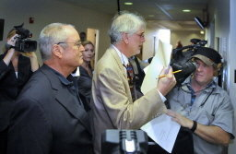**AP Photo/ Mail Tribune, Jim Craven**This September 2009 file photo shows James Auchincloss (left) and his attorney, Carl Caplan, waiting for an elevator in the Jackson County courthouse in Medford.

MEDFORD, Ore. (AP) -- A former employee who alerted police that the half brother of Jacqueline Kennedy Onassis had a collection of child pornography is claiming whistleblower protection and suing for $1.5 million.

The Mail Tribune reported Wednesday that Edward McManus, a former assistant, is seeking back wages and damages from James Auchincloss of Ashland.

Auchincloss pleaded guilty in 2010 to two felony counts of encouraging child sexual abuse for having computer images of naked boys.

A lawyer for McManus argued in court that he is protected by the whistleblower law because he exposed illegal activity in his workplace.

A lawyer for Auchincloss countered that McManus had no contract and could have looked away.

Judge Ron Grensky said it was hypocritical for McManus to keep working for Auchincloss after seeing the child pornography.

View Comments